**NOTIFICATION GUI DOCUMENTATION**

**INSTALLATION:**

* Create a global private NotificationGUI object as follows: 
* Add the NotificationGUI as the first entry to your rootPanel. It should look sort of like this:

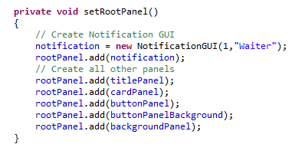

* The NotificationGUI is initialized with 2 parameters, as you can see in the picture above:
  + Parameter 1: Employee ID
    - This is an integer which is assigned the currently signed in employee
    - Since we don’t log in from the database at the moment, any random employee ID will be fine for now
  + Parameter 2: Employee class
    - This is the actor assigned to the currently signed in employee
    - NOTE: YOU ONLY HAVE 6 OPTIONS FOR THE EMPLOYEE CLASS PARAMETER. Options are as follows:
      * Host
      * Busboy
      * Manager
      * Customer
      * Waiter
      * KitchenStaff

**USAGE:**

* Most of the work has been done for you, you can manually send any messages without any changes.
* To view your notification bar, drag your mouse over the date and time and click
* For sending automatic messages, you will use the sendMessage() function: 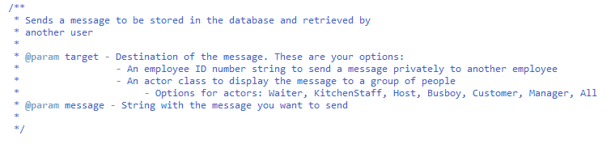
* Example code for that:



* To remove messages from your bar:
  + Click on the message
  + Complete the acknowledge prompt